**The Elements of Music**

C:\Documents and Settings\bprior\Local Settings\Temporary Internet Files\Content.IE5\7LFLXRWF\MCj04413980000[1].wmf

MC900250417[1]

Pitch

High and low

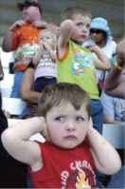

 Duration Dynamics

Beat (notes the same length) Loud and soft

and rhythm (notes different lengths)

Tempo Timbre Texture

**Fast and slow Type of sound Layers in the music**

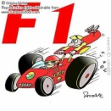

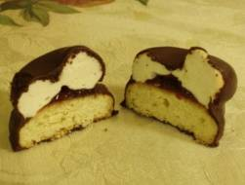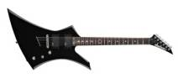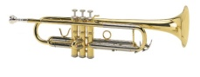

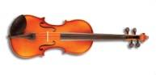

**Italian Terms: optional - you will not gain extra marks**

Use when describing music

To describe the tempo:

adagio = slow

allegro = fast

moderato = a medium speed

accelerando = getting gradually faster

rallentando = getting gradually slower

 

To describe the dynamics:

Forte = loud

Piano = soft

Mezzo forte = medium loud

Mezzo piano = medium soft

Crescendo = gradually getting louder

Diminuendo = gradually getting softer

 

keywords

**12 Bar Blues**

**12 bar blues** *– traditional length of a verse in a Blues song*

**AAB** *– the structure of the lines of lyrics in a Blues song. The first and second lines are the same and the third is different.*

**Harmony** *– the chords used to accompany the melody*

**Metre** *– A Blues has 4 beats in a bar or a time signature of 4/4*

**Swing rhythm** *– the ‘humpty-dumpty’ rhythm*

**Improvisation** *– making up a melody on the spot*

**Spiritual** *– a religious song which influenced the Blues with its expressive singing style, slow tempo and lyrics about life*

**Work song** *– a song to work to which influenced the Blues with its steady beat, call and response and lyrics about life*

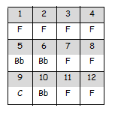

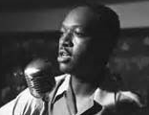

***Instruments associated with the Blues***

Voice

Guitar

Electric Guitar (from 1940 onwards)

Harmonica

Piano

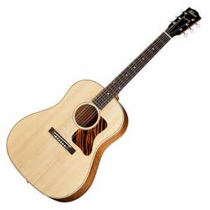

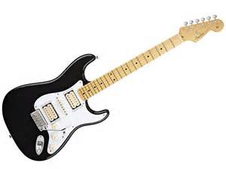

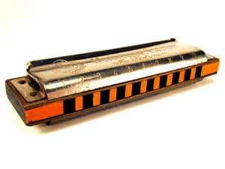

[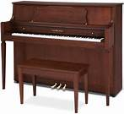](http://www.bing.com/images/search?q=piano&qs=n&form=QBIR&scope=images&pq=piano&sc=8-5&sp=-1&sk=#view=detail&id=49FBB665E1127F4776146CA16A30335AA35D3958&selectedIndex=10)

**The impact of the Blues….**

The Blues went on the influence other styles of music.

In 1950’s, Rock and Roll musicians used 12 bar blues harmony as a basis for their songs. In songs like; Jailhouse Rock and Rock Around the Clock. From then on, the Blues influenced Rock and Pop music.

[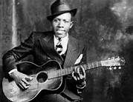](http://www.bing.com/images/search?q=blues+singer&qs=n&form=QBIR&scope=images&pq=blues+singer&sc=8-12&sp=-1&sk=#view=detail&id=0DA4A57336F71B9E2D8911FB8E279BAC0D022D7D&selectedIndex=0)