Programme music keywords

STRING TECHNIQUES

***Arco*** *–using the bow*

***Pizzicato*** *– Plucking the strings*

***Tremolo*** *– rapidly moving the bow backwards and forwards across a string to make a trembling sound. Used to create a feeling of tension*

***Double Stopping*** *– playing more than one string at a time*

[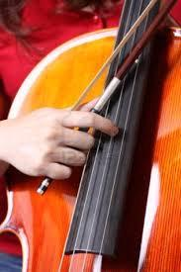](http://www.google.co.uk/imgres?q=pizzicato&start=210&safe=active&hl=en&biw=1366&bih=673&tbm=isch&tbnid=_Q5PPYut7-TXeM:&imgrefurl=http://www.123rf.com/photo_5759986_cello-pizzicato.html&docid=YsVuDTPo-MTG5M&imgurl=http://us.123rf.com/400wm/400/400/oldapple/oldapple0910/oldapple091000018/5759986-cello-pizzicato.jpg&w=801&h=1200&ei=gEB6Uau5MOWA7QaZt4GACg&zoom=1&ved=1t:3588,r:15,s:200,i:49&iact=rc&dur=400&page=9&tbnh=190&tbnw=132&ndsp=25&tx=113&ty=90)

[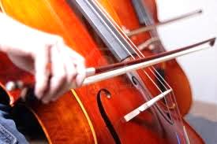](http://www.google.co.uk/imgres?q=pizzicato&start=210&safe=active&hl=en&biw=1366&bih=673&tbm=isch&tbnid=Tk01QU9oUMZloM:&imgrefurl=http://www.123rf.com/photo_5818119_cello-pizzicato.html&docid=ZzCKuV407qlcFM&imgurl=http://us.123rf.com/400wm/400/400/oldapple/oldapple0910/oldapple091000038/5818119-cello-pizzicato.jpg&w=1200&h=801&ei=gEB6Uau5MOWA7QaZt4GACg&zoom=1&ved=1t:3588,r:12,s:200,i:40&iact=rc&dur=805&page=9&tbnh=183&tbnw=275&ndsp=25&tx=114&ty=103)

TONALITY

***Major******key*** *– the music is based on a major scale to create a ‘happy’ or ‘triumphant’ feeling or mood*

***[](http://www.google.co.uk/imgres?q=happy&start=224&safe=active&hl=en&biw=1366&bih=673&tbm=isch&tbnid=rltCYpUJHLxkjM:&imgrefurl=http://www.sodahead.com/fun/wont-you-join-me-in-wishing-a-happy-birthday-to-our-dear-sweet-friend-fairlady/question-2580693/?page=6&docid=e_SKxhq-niJ0rM&imgurl=http://4.bp.blogspot.com/_4BCfNcrL_aM/TRq4zalOscI/AAAAAAAABSA/RQA1YTIN-Dw/s1600/thumbs+2+up+smiley.gif&w=654&h=398&ei=ZEl6UcamOLPB7AbUzoDoDg&zoom=1&ved=1t:3588,r:25,s:200,i:79&iact=rc&dur=542&page=11&tbnh=163&tbnw=268&ndsp=23&tx=156&ty=102) Minor key****– the music is based on a minor scale to create a ‘sad’ or ‘eerie’ feeling or mood*

*[](http://www.google.co.uk/imgres?q=sad&safe=active&hl=en&biw=1366&bih=673&tbm=isch&tbnid=Bcym5Z16CKQ39M:&imgrefurl=http://hubpages.com/hub/are-you-sad-and-dont-want-to-be&docid=F9XRTw18CW3DiM&imgurl=http://s1.hubimg.com/u/3055436_f520.jpg&w=520&h=546&ei=gFF6Ua7_DY-RhQe-4YHACA&zoom=1&ved=1t:3588,r:54,s:0,i:250&iact=rc&dur=285&page=3&tbnh=167&tbnw=159&start=46&ndsp=25&tx=65&ty=94)*

**TIME SIGNATURES**

***3/4*** *– 3 beats in a bar, also known as ‘waltz’ time.*

***4/4*** *– 4 beats in a bar.*

***Free time -*** *when there is no set pulse or beat in the music [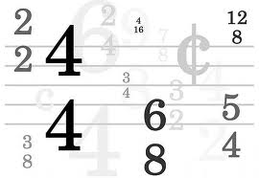](http://www.google.co.uk/imgres?q=time+signature&safe=active&hl=en&biw=1366&bih=673&tbm=isch&tbnid=UCsnWgEufdkKhM:&imgrefurl=http://www.gethatched.ca/2011/07/07/time-signature-geek-a-palooza/&docid=gRIcwARbrx43lM&imgurl=http://www.gethatched.ca/wp-content/uploads/2011/07/TimeSignatures-main_Full.jpg&w=600&h=414&ei=N1p6UcW0INCWhQerhoD4BA&zoom=1&ved=1t:3588,r:10,s:0,i:110&iact=rc&dur=1964&page=1&tbnh=161&tbnw=235&start=0&ndsp=17&tx=141&ty=51)*

***Repetition -*** *one instrument copies what the other has played*

***Sequence –*** *a melody or pattern of notes that is repeated at a higher or lower pitch*

***Ostinato –*** *a short repeating pattern*

**Italian Terms: optional - you will not gain extra marks**

Use when describing music

To describe the tempo:

adagio = slow

allegro = fast

moderato = a medium speed

accelerando = getting gradually faster

rallentando = getting gradually slower

 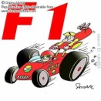

To describe the dynamics:

Forte = loud

Piano = soft

Mezzo forte = medium loud

Mezzo piano = medium soft

Crescendo = gradually getting louder

Diminuendo = gradually getting softer

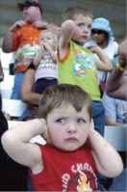 

**The Elements of Music**

C:\Documents and Settings\bprior\Local Settings\Temporary Internet Files\Content.IE5\7LFLXRWF\MCj04413980000[1].wmf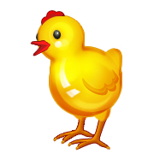

MC900250417[1]

Pitch

High and low



 Duration Dynamics

Beat (notes the same length) Loud and soft

and rhythm (notes different lengths)

Tempo Timbre Texture

**Fast and slow Type of sound Layers in the music**



