Instruments of the orchestra
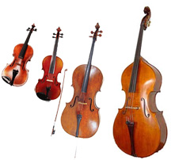
SRING FAMILY – strings vibrate to make a sound

Violin (High) Double Bass (Very Low)

Viola (Medium high)
Pizzicato = plucked
Arco = use a bow
Double stopping =
2 strings played
Tremolo = very quick repeated notes using a tiny amount of bow.

Bow (Used to play all four)

Cello (Medium and low)

BRASS FAMILY – the player’s lips vibrate to make a sound
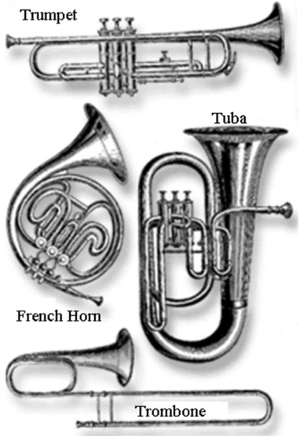

(High)

(Medium)
(Very Low)

Slide
(Medium and low)

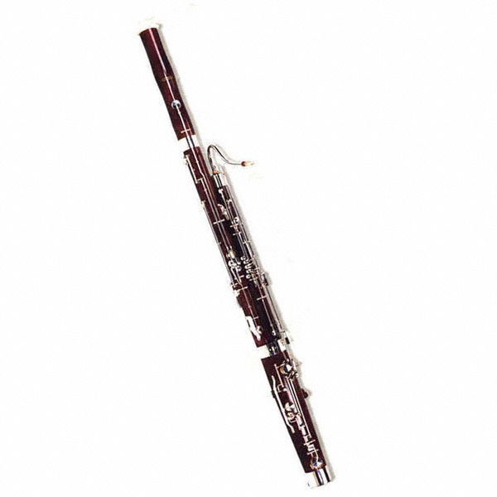
WOODWIND FAMILY – reeds vibrate to make a sound (except for the flute)
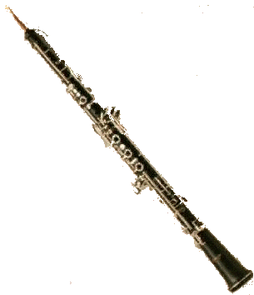
Oboe(High – double reed)
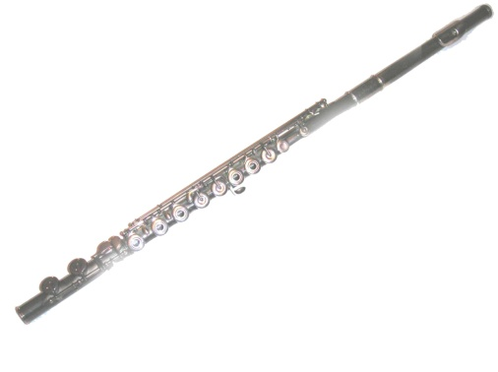
Flute (High – no reed)

Bassoon(Medium and Low –
double reed)
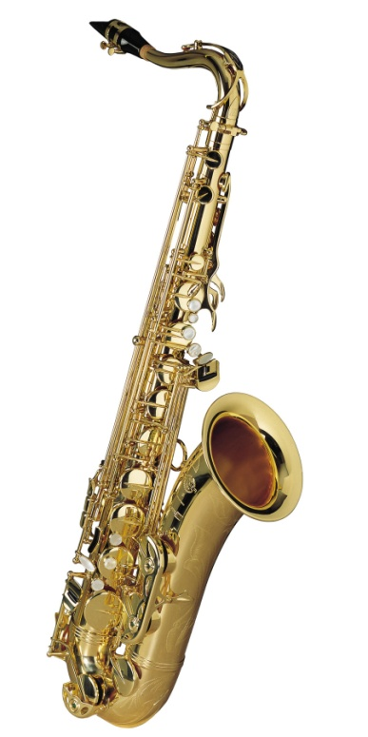

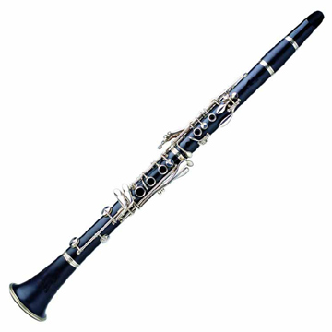

Clarinet Saxophone
(High and medium – (Different sizes produce different pitches
single reed) – single reed)

PERCUSSION FAMILY – something is struck to produce a sound
Cymbals
Bass drum
Glockenspiel (Bars are made of metal)
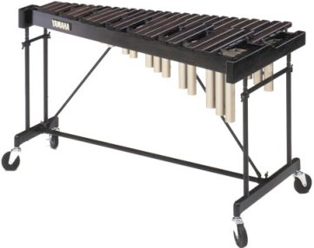
Timpani drums
Snare drum
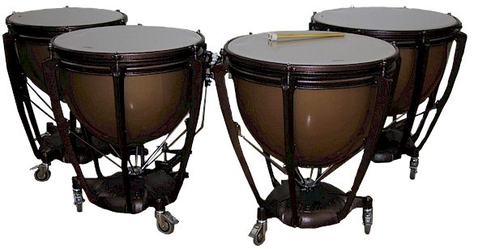

Xylophone
(Bars are made of wood!)

