2017 Anticipated Movies

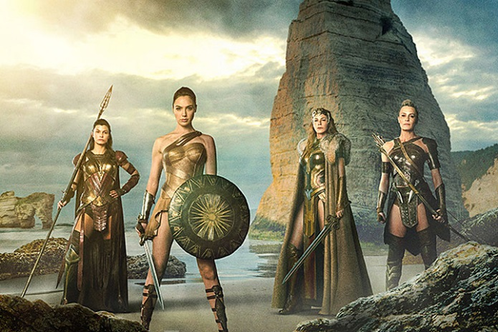

1) Wonder Woman
The first ever movie with a strong comic heroine has got high hopes from fans, as this could be the heroine movie some have waited decades for. Wonder Woman is being played by Gal Gadot and brings a hopeful portrayal for the much loved heroine. The DC film industry has had mixed reviews, so many hope Wonder Woman will be the start of an entertaining cinematic universe.

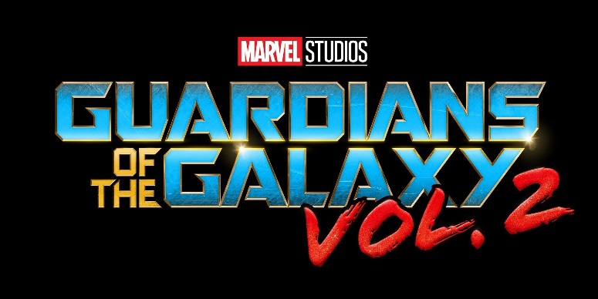

2) Guardians of the Galaxy Vol. 2
The first Guardians of the Galaxy had very positive reviews from old and new fans to the franchise. The sequel, according to the director James Gunn, will surpass the first Guardians of the Galaxy with all your favourites but this time more action and comedy to entertain any generation of fans.

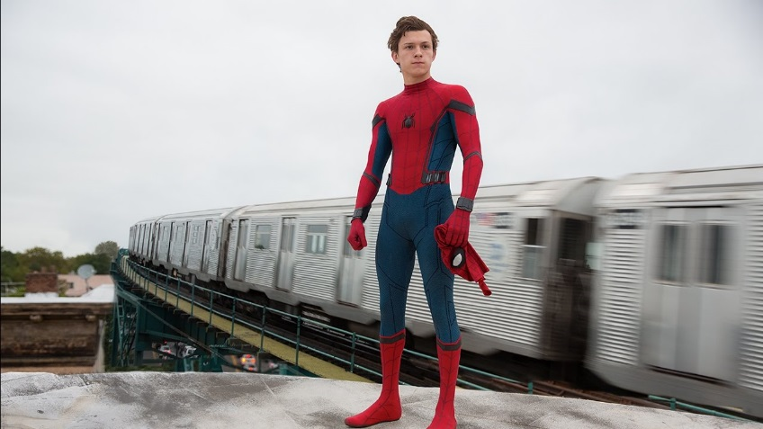

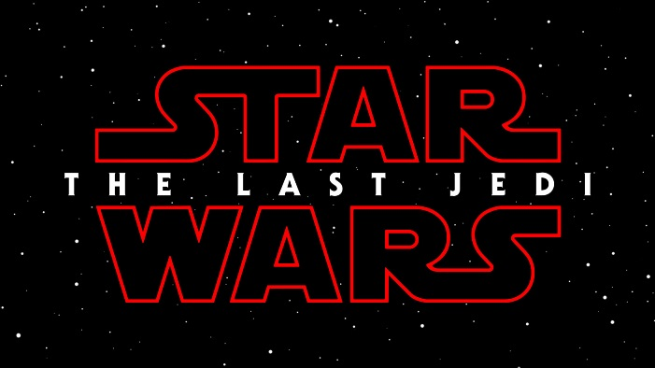
3) Spider-Man Homecoming
Spider-Man is one of the most popular characters, and has had 5 movies in total. But unlike before, this will be the first time Spider-Man is made by Marvel Studios, promising a heroic return to the screen for the web slinger. Tom Holland is playing the popular hero and shows huge potential to star as Spider-Man.

4) Star Wars the Last Jedi Not much is known about the plot or characters of the next instalment of the new Star Wars trilogy, but much anticipation is building on who the title is referencing to. The Force Awakens and Rogue One have both been successful in the box office, so many are preparing themselves for what is to come.

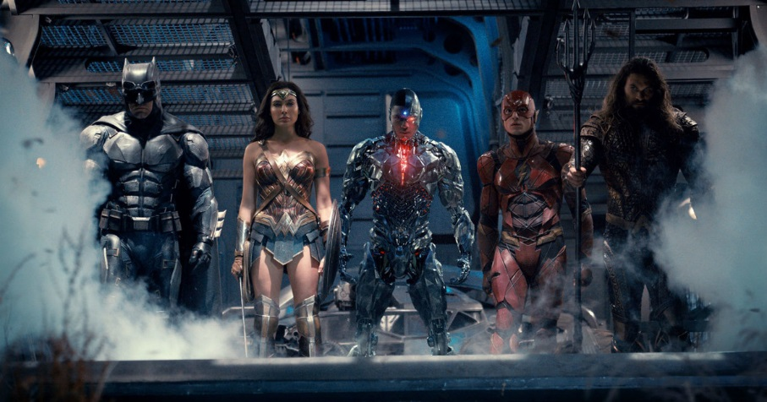

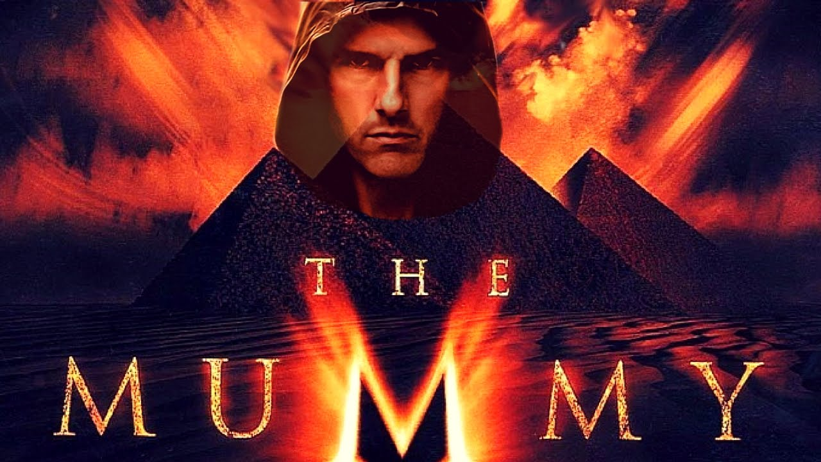
5) Justice League
The Avengers of the DC universe have been rumoured to have a movie since 2012, now that the rumours are confirmed there is a lot of curiosity around fans as to how this movie will go. The director has confirmed 5 comic heroes to be a part of the Justice League (Batman, Wonder Woman, The Flash, Aquaman and Cyborg) it also has a lot of speculation as to who else might feature.

6) The Mummy
Tom Cruise stars in this reboot of the well-known Mummy franchise. The trailers promise a thriller of epic proportions and may deliver surprise audiences who were fans of the previous Mummy movies, a thriller to look out for.
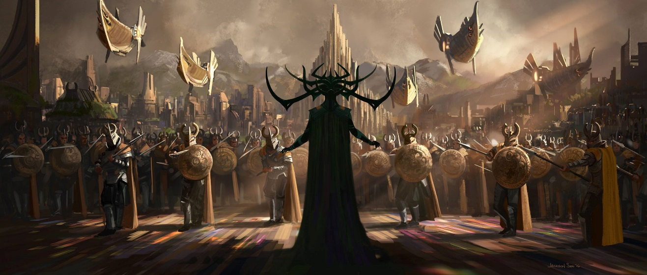
7) Thor Ragnarok
The third and final instalment of the Thor trilogy showcases Chris Hemsworth starring as the popular God of Thunder, with not one but two popular storylines. The movie will be based on the Ragnarok storyline from the comics, but also features the Planet Hulk storyline.
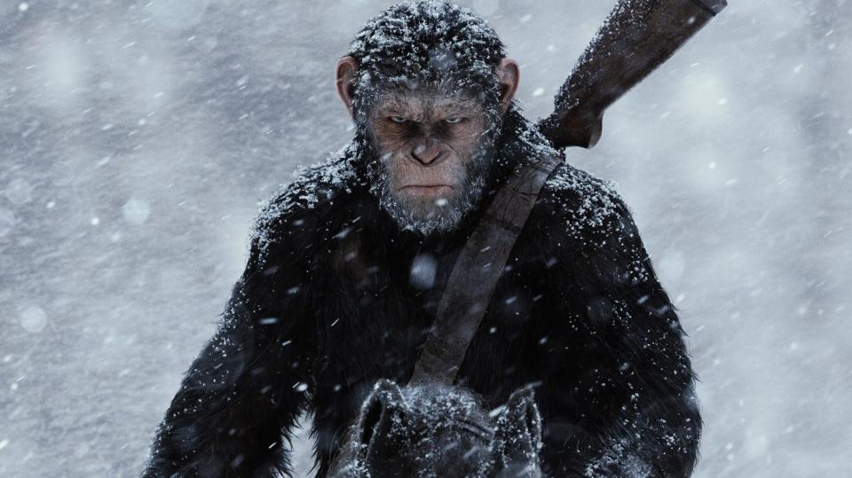

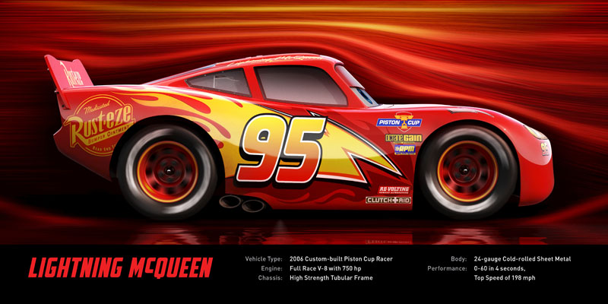
8) War for the Planet of the Apes
The popular Planet of the Apes franchise is back with another film. This next movie shows what could be a conclusion to the beloved franchise or another steppingstone for future plans in the box office. Caesar played by Andy Serkis is still in deadly conflict and now is the leader of an army who are going to war.

9) Cars 3
Cars has been a much loved Pixar franchise from kids and adults alike, the next instalment shows Owen Wilson reprising his role as McQueen in what seems to be a different take on the Cars universe, with upgraded CGI and a much more complicated storyline, Cars 3 seems to be very different from previous films.
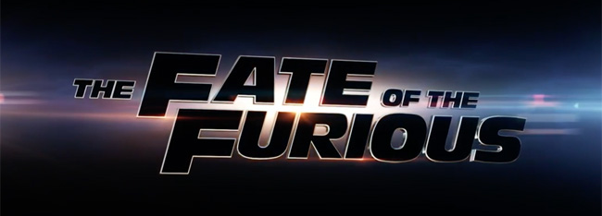

10) The Fate of the Furious
The eighth movie in the Fast and Furious franchise shows the same fast cars and impossible stunts that fans have grown to love. Vin Diesel, Dwayne Johnson and Paul Walker reprise their well-known racing characters. The movie probably won't be the last, but it has progressed to emotional storylines that can bring new experiences.
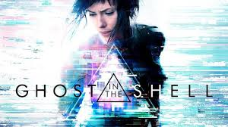

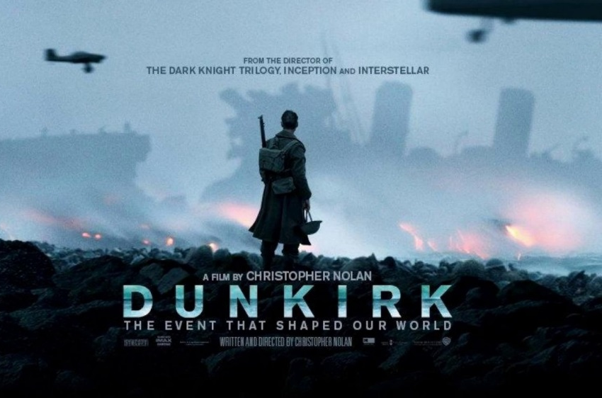
11) Ghost in the Shell
Based on the popular anime made by Mamoru Oshii, the film adaptation is starring Scarlett Johansson and shows to be true to the anime. The anime was made in and was very popular among new and old anime fans, the film has a lot to live up to but it is possible to live up to the standards of Mamoru Oshii's masterpiece.

12) Dunkirk
Box office director Christopher Nolan directs a movie based on the events of Dunkirk in World War 2. The film will show the tragedies and horror of the war, and promises to be truthful to the actual events, showing a dark and gritty period of history.

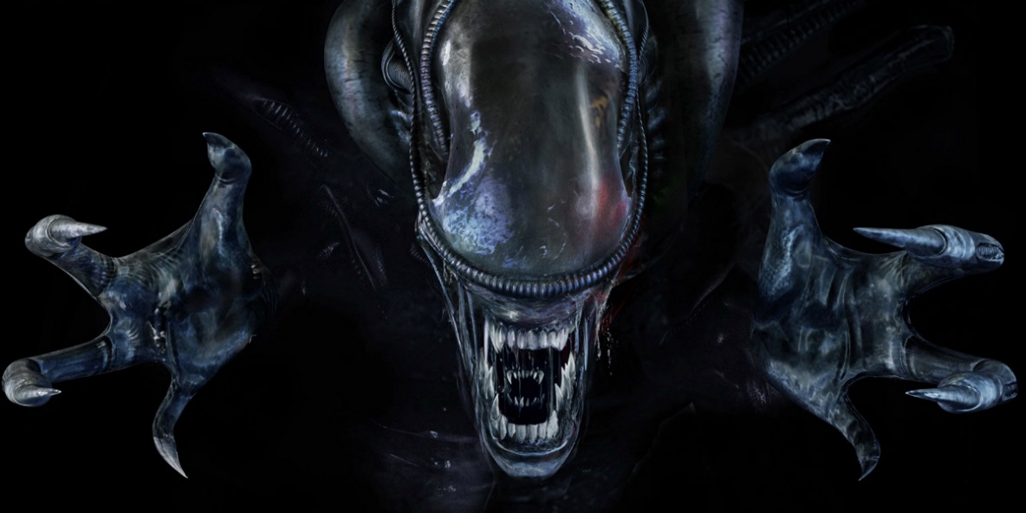

13) Alien Covenant
Alien is being rebooted to suit this generation of horror and thriller audiences. The film will be a thriller based off of the popular franchise the new reboot could be either a standalone movie, or the start of future Alien films to come. Fans are excited to see what this movie will bring to the Alien movies.

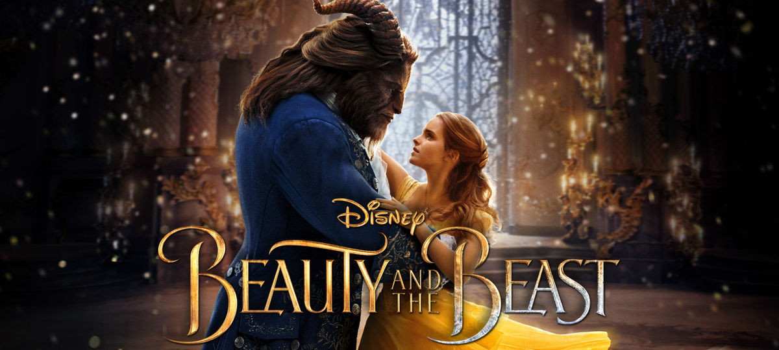
14) Beauty and the Beast
A reboot to the much loved 1991 Disney classic shows potential on showing a new twist on the tale as old as time. Disney has had success with similar reboots (Maleficent, Cinderella, Jungle Book etc.) Beauty and the Beast is the next classic to be rebooted with Emma Watson as Belle and Dan Stevens as the beast.

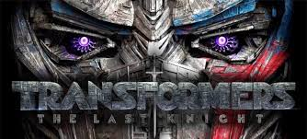

15) Transformers the Last Knight
Transformers have had mixed reviews among critics and fans, but the fifth instalment might be a change in the new direction. Transformers puts the storyline and characters into a different direction which could redeem what was a popular kids show and an intriguing concept to the heights people want to experience.

