Year 7 revision
Food Technology
- Tools and equipment – You need to be able to recognise the following pieces of equipment and explain what they do.
Name | Use/description
Colander | - These are used to drain off liquid from food after washing or cooking.
Wok | This is a bowl-shaped frying pan used typically in Chinese cookery.
Measuring jug | This is a jug or cup marked up in graded amounts, used in cooking.
Baking tray | This is a metal tray on which food may be cooked in an oven.
Wooden spoon | This is used to stir ingredients. It is sometimes preferred to plastic utensils because it does not melt.
Rolling pin | This cylinder rolled over pastry or dough to flatten or shape it.
Electronic measuring scales | These are used to measure ingredients.
Garlic crusher | This is a specific tool used to crush garlic
Microwave | This is an electronic device that is used to cook food.

- Health and safety – you must know at least 6 different ways to be safe in a kitchen.

- Labelling the cooker – you need to know the different parts of the cooker
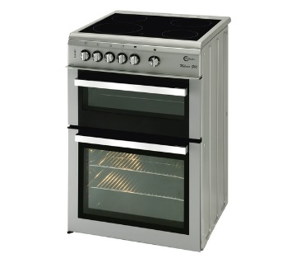
Hob
Grill

Temperature dial
Oven

- You need to know the following technical terms:
Technical term | Meaning/definition
Steaming | This is a method of cooking that uses steam. This is often done in a food steamer.
Poaching | This is a way of cooking food using a small amount of liquid.
Toasting | This is when you cook or brown (food, especially bread or cheese) by exposure to a grill, fire, or other source of radiant heat.
Roasting | The action of cooking something in an oven or over an open fire.
Frying | This is where food is cooked in hot fat or oil, typically in a shallow pan.
Grilling | This is where you cook food using the grill in the oven. This is a healthier way than frying as excess fat is lost from the product.

Product Design
- Tools and equipment
Name | Use/description
File | - A file is a metalworking, woodworking and plastic working tool used to cut fine amounts of material from a work piece.
Scroll or fret saw | This is an electronic saw used for intricate cutting work which often incorporates tight curves.
Glass paper | This is a type of abrasive paper that is used to smooth material to ensure a high quality finish.
Pillar or bench drill | This is a machine used to create holes in a piece of material.
Coping saw | - This saw has a very thin blade stretched across a D-shaped frame and is used to cut intricate patterns into wood, by hand. It is similar to a fret saw.
Tenon saw | A small saw with a strong brass or steel back for precise work. It is usually used for cutting straight cuts in wood.
Scissors | This is a tool used for cutting material such as paper or card.
Try square | A try square is a woodworking or a metal working tool used for marking and measuring a piece of wood. It uses a right angle (90 degrees) to accurately create a straight line.

- Technical terms
Technical term | Meaning/definition
Annotation | This is a way of explaining something using a detailed comment.
Design brief | A design brief is a written document for a design project. It is a brief comment that informs the designer about what they are creating.
Environment | The surroundings or conditions in which a person, animal, or plant lives or operates.
Function | This refers to what a product does.
Recyclable | This is a process that enables a product to be reused.
Target user | This is a specific person or group who potentially could use the product. This usually includes a specific gender and age range.
Manufacture | This is to make (something) on a large scale using machinery.
Form | This is the way in which something exists or appears. E.g. the shape.

- Health and safety – you must know at least 5 health and safety points that must be followed in a workshop.

- You must know at least 3 different woods, metals and plastics.
- Woods: pine, mdf, plywood, beech, mahogany
- Metals: Aluminium, pewter, cooper, steel
- Plastics: Acrylic, polypropylene, HIPS, ABS

- You need to know the difference between hardwoods and softwoods
Soft Woods | Hard Woods
These come from coniferous trees that have needles instead of leaves. These trees grow all year round. They are usually cheaper. Examples include: pine and red deal. | These come from deciduous or broad-leafed trees. They are generally slow growing. Examples include mahogany, oak, beech, teak and ash.

- Packaging and labelling – below are items that should be included on packaging:
  - Logo
  - Bar code
  - Price
  - Ingredients
  - Recycling information
  - Allergy information
  - Slogan

Textiles
- Tools and equipment
Name | Use/description
Needle | - This is a piece of equipment that contains an ‘eye’. It is used to attach two pieces of material together.
Pin | This is used to hold two pieces of material together. It has a flat end on one side.
Bobbin | This is a part of a sewing machine. It holds thread.
Bobbin holder | This is the container for the bobbin in a sewing machine.
Spool pin | This is a part of a sewing machine. It holds the main cotton reel.
Material scissors | - This is a tool specifically used for cutting fabric materials.
Stitch ripper | This is a tool that is used to remove unwanted stitches.
Tailors chalk | This is a type of hard chalk that is used in textiles to mark out material.

- Materials – synthetic and natural
Synthetic | Natural
These materials are man-made. They are cheaper and easier to make. Examples include polyester, nylon, acrylic and viscose. | This type of fibre is made from natural plants and animals. They are more comfortable but more expensive. Examples include wool, silk, cotton and linen.

- Definitions:
- Upcyling: This is when a product is reused to create a new and exciting product of higher quality or value than the original.
- Applique: This a technique that involves layering materials on top of each other to create surface detail.

- Sewing machine – you need to make sure that you know all the parts of a sewing machine.
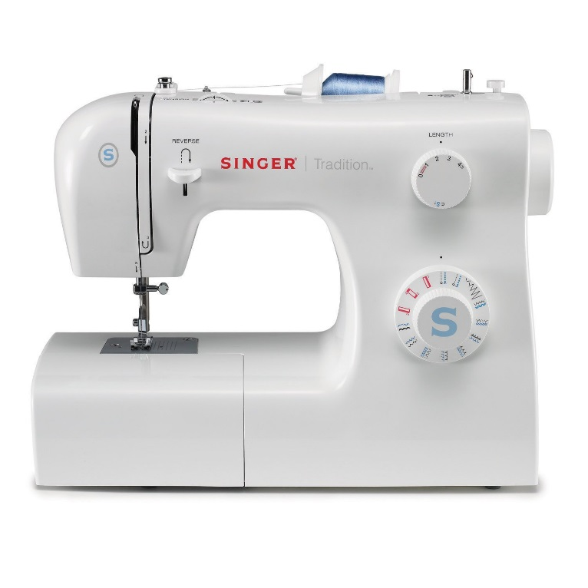
Spool pin
Hand wheel

Stitch length selector
Reverse stitch lever
Stitch selector
Pressor foot

- Stitches – you need to be able to recognise the following stitches:
  - Running stitch
  - Back stitch
  - Lazy daisy stitch
  - Blanket stitch
  - Cross stitch

