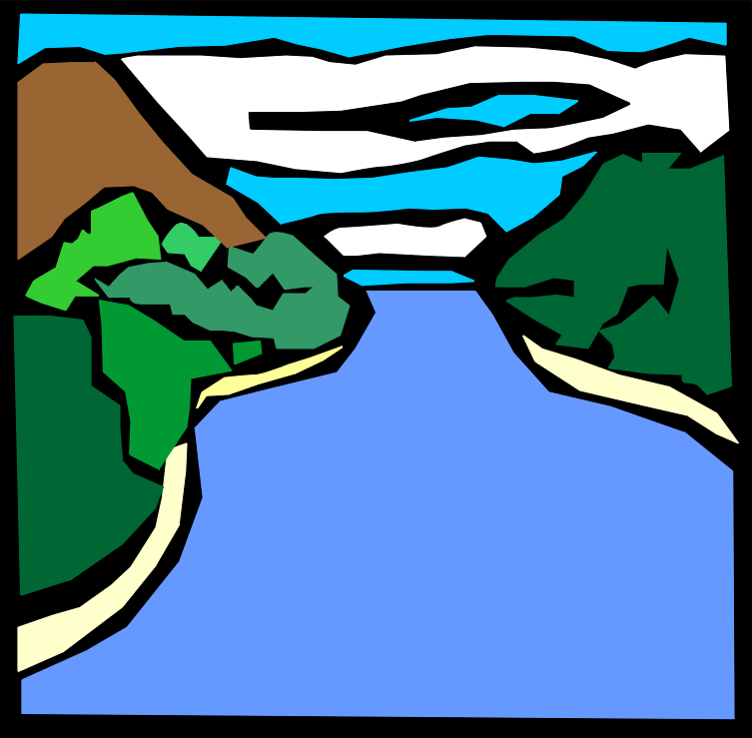
Year 7 Geography Revision Booklet – Rivers
Name:
Class:
Teacher:

Your exam will be in the dates from Monday 6th June to 17th June. Your teacher will set each week some revision for you to complete. This is like homework and not optional. This is the minimum you should think about doing. You will need to read through your notes two or three times in the lead up to your exam.

Week beginning | Task | Due
2nd May | Revision poster on the different processes:  - Erosion  - Transportation  - Deposition
9th May | Flash cards showing the formation of waterfalls AND ox-bow lakes
16th May | Practice exam question: Describe the responses to a flood using a case study (8 marks)  Help:  - Introduce the case study  - X3 PEEL paragraphs about a response to the flood
Over half term | A3 mind map on the whole unit

Processes of erosion
- Erosion – the wearing away of the bed and banks
Name of erosion process | Description
Hydraulic action | The sheer force of the water hitting the bed and banks
Abrasion | When rocks are scraped against the beds and banks
Attrition | Rocks hitting each other and getting smaller
Solution | The water dissolving the rocks such as limestone

- Transportation – the movement of the eroded material
Name of erosion process | Description
Traction | When the largest material is rolled along the bed
Saltation | When small pebbles bounce and leap-frog over each other
Suspension | When small particles such as sand are carried floating in the river
Solution | The dissolved material is carried by the river

- Deposition – the dropping of the eroded material due to a loss of energy

How does a river changes down its valley?
 | Upper | Middle | Lower
Gradient (steepness) | Very steep | Flatter | Flattest
Width | Narrow | Wider | Widest
Valley shape | V shaped and steep sides | U shaped, flatter sides | Very wide U shape with very flat sides

Formation of a waterfall
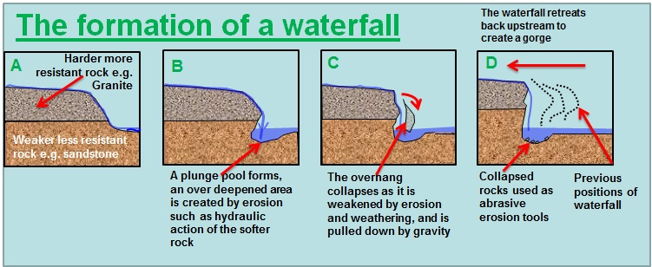
- Hard rock overlays softer less resistant rock.
- As the river flows it erodes the softer rock first and the harder rock second.
- The material broken off swirls around at the bottom of the river creating a plunge pool.
- The hard rock forms an overhang which collapses.
- This process continues over repeats and a waterfall is formed.
Labelled waterfall diagram
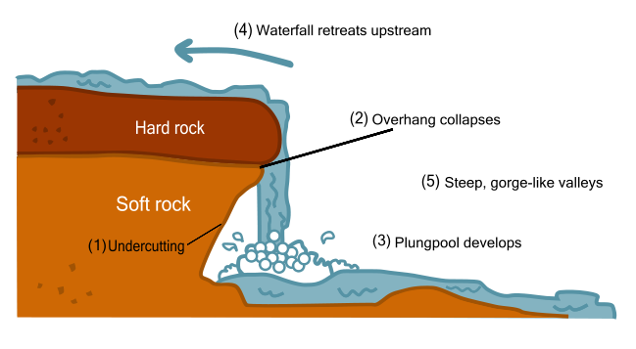
Plunge pool develops

Formation of an ox-bow lake
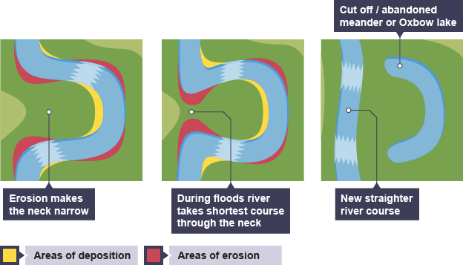
- Erosion on the outside of the bends make the neck narrow
- The neck gets narrower because of hydraulic action and abrasion
- During a flood the river breaks through the neck as it takes the shortest course
- The bend is cut off forming an ox-bow lake
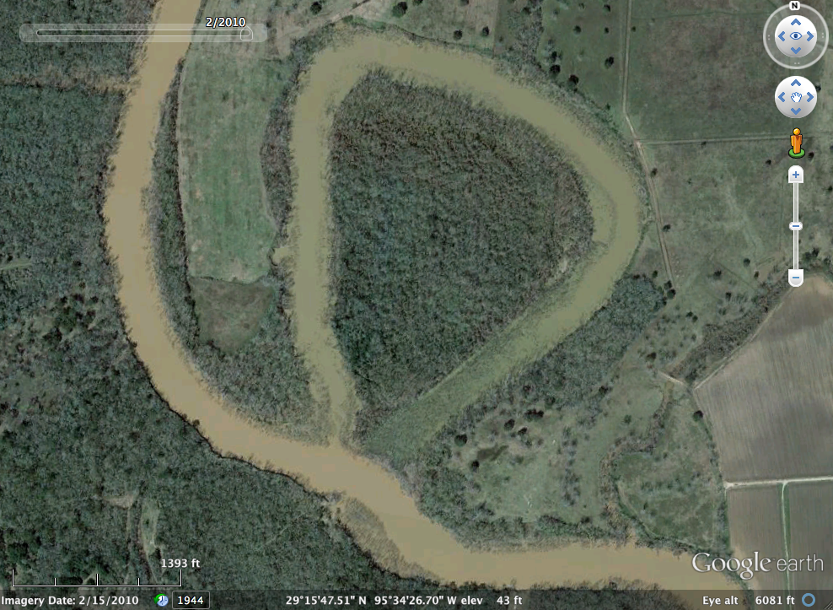
Labelled ox-bow lake diagram
Deposition
Ox-bow lake

Floodplain
Causes of a flood
Cause | Explanation
Heavy rainfall | When rainfall is heavy, soil may become saturated more quickly, leading to less infiltration and increased surface run off, causing discharge to increase more quickly and possible flooding.
Snowmelt | During spring extensive melting of snow may cause an increase in water within the river system, increased discharge and potential for flooding.
Deforestation | Fewer trees lead to decreased interception of rainfall, resulting in shorter lag times and rapid rises in discharge leading to potential flooding.
Building construction | Impermeable surfaces associated with urban areas, will reduce infiltration, increase surface run off, shorted lag times and increase rise in discharge leading to possible flooding.

Case study: The Boscastle Flood
You need to be to talk about the following:
- Cause – what made the flood happen
- Effects – what changes happened due to the flood
- Responses – what people did to help after the floods

The cause:
- Over 60 mm of rainfall (typically a month's rainfall) fell in two hours.
- The ground was already saturated due to the previous two weeks of above average rainfall.
- The drainage basin has many steep slopes, and has areas of impermeable slate causing rapid surface run-off.
- Boscastle is at the confluence (where tributaries meet) of three rivers - Valency, Jordan, and Paradise. A large quantity of water all arrived within a short space of time causing the rivers to overflow.
- The flooding coincided with a high tide, making the impact worse.

The effects:
Social effects (people) | Economic effects (money) | Environmental effects (nature/wildlife)
- 58 properties destroyed  - 84 cars wrecked  - 60 people evacuated | - Damage to infrastructure – some roads completely impassable  - 3 shops destroyed  - 4 footbridges washed away and structural damage to road bridge  - Car parks washed away  - Insurance companies had to pay out thousands for the damage  - ‘Witchcraft Museum’ – was destroyed and led to lower tourism numbers | - Trees uprooted and washed downstream  - Soil erosion  - 20 tonnes of soil moved and deposited  - Sewers burst

The responses:
Immediate responses (days/weeks after)
- Helicopters from RAF and Navy
- Buildings searched
- Trees removed
- Roads cleared
- Sandbags put in place
Long Term Responses (months/years after)
- £4.5 million flood defence scheme
- drainage systems improved
- channels widened and deepened
- banks of river reinforced

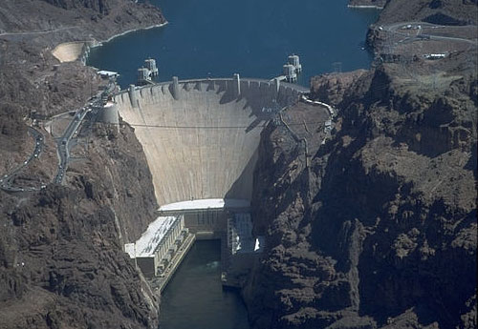
Flood management
1. Dam
Definition: Dams are huge walls built across the rivers, usually in the upper course.
Example: Katse Dam, Lesotho
Advantages | Disadvantages
Generate electricity | Expensive
Stop flooding downstream | Land is flooded behind the dam
Provide jobs during construction and maintenance of the dam | People may have to move due to flooding behind the dam wall

Other methods of flood management
What is it? | Advantages | Disadvantages
2. Afforestation – planting trees which can help to absorb some of the water | It is cheap  It makes the valley look nicer with more trees | Does not stop flooding
3. Managed flooding – the river can flood naturally in places to prevent flooding further downstream | It costs nothing | Does not stop flooding
4. River straightening – the channel can be widened or deepened so that water can travel faster along the river | The channel of the river can be altered, diverting floodwater away from settlements | Expensive  Altering the river channel may lead to a greater risk of flooding downstream, as the water is carried there faster

