Year 7 Revision Checklist: Terrible Tudors!
For you summer exam, you will be tested on the Tudor England Unit.
Top Revision tips:
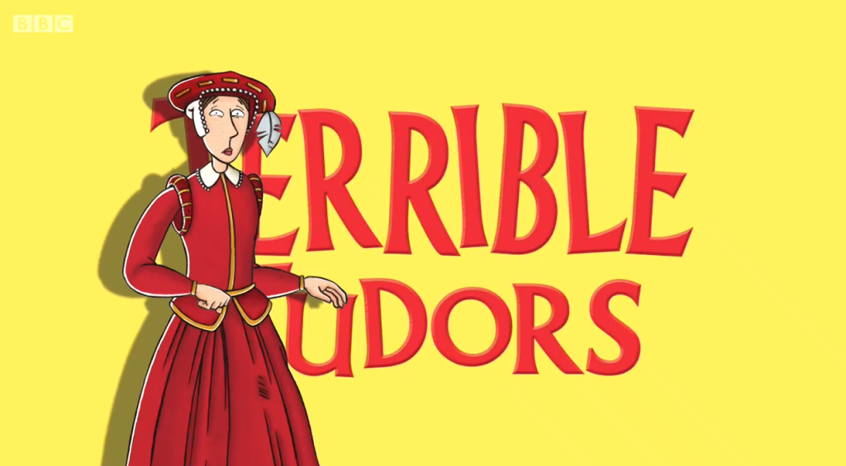
- Create a mind-map or poster on each topic using key words
- Create flash cards on each topic
- Complete the revision material given by your teacher
- Create a quiz and test your friends

Topic: | Revised Once: | Revised twice:
Who Henry VIII was?
Henry VIII’s wives and children (names)
The problems with Henry VIII’s wives
The Mary Rose, what happened when it sank and the reasons it sank.
The Break with Rome (What happened when Henry changed religion)
What motivated Henry VIII to break with Rome.
Mary I’s changes to the church.
Why Mary I got the nickname ‘Bloody Mary’
Elizabeth I and her marriage problems
Elizabeth I and her problems with Mary Queen of Scots.
The events of the Spanish Armada
What types of question will be on my exam:
Describe questions | 4 marks | 1 PEEL paragraph (5 minutes)
Source questions: Comparison | 4 marks | Quote and explain and infer from each source to explain (10 mins)
Source Question: What can you learn or how does the sources support? | 4 marks | Quote and explain and infer from each source to explain (10 mins)
Judgement question, where you compare reasons for an event or outcome | 12 marks | 1 paragraph on each reason  Conclusion with a judgement.  (15 mins)

