IS THE CURRICULUM GOOD ENOUGH FOR STUDENTS?
Ewan Wilson (Year 9)

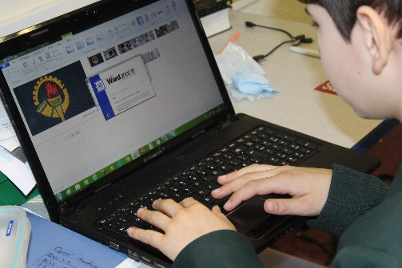
Our school curriculum changes constantly; whether the fact it is because all students, every year, are achieving A*s, or just because students need to become clever in society, our curriculum changes and it doesn’t make everyone happy. When a student finishes college in England, they have the free choice to join a university; this resulting in them, in most occasions, leaving home and renting/buying a place to live. Here they must cook, clean, pay bills, manage money and learn life the hard way. However, the only reason why students must learn life the hard way after school is because of the constant change in the curriculum. Do the government ever take suggestions from teachers, students, citizens to how the curriculum should be? Surprisingly, they do accept suggestions and comments from people; however, it has never and assuming never will, changed the government’s final decision. When leaving school, does a student know how to pay a mortgage? Does a student know how to obtain a national insurance number for an upcoming interview? Does a student even know how to prepare for an interview? Sadly, most students don’t know this. We want the next generation to be prepared, not to face the battles of hard life straight on without tactics! As the more experienced generation, we should have a say in what our children should be learning in school. Take the example of Maths, a necessary subject to take for GCSEs and a subject needed to pass in life. Modules in Maths such as area, perimeter, basic multiplication, time, distance, imperial and metric units are a key skill to survive the adventure of life. However, when a student is in class learning things such as quadratic sequences, surds and advanced algebra, how will this help students in future life? Toothill school’s BBC School Report asked Miss Day, a trainee teacher at Toothill School training in English, her thoughts on the curriculum. She does not like how we no longer study international authors for GCSE and only study English novels such as Pride & Prejudice. “How can I intrigue a 15-year-old boy into a romantic classic novel?” tells Miss Day. We should be learning life skills as a core subject, replacing those modules from other subjects. We should attack this problem head on, engage it directly by addressing the government of the changes we want to make to the curriculum. We should, and we deserve, the future generation to have tactics in the battle of life ahead of them. The government should listen to our suggestions after all, it is for the children of tomorrow.

