The Nintendo Switch: What you need to know
Nintendo released their brand new console the Nintendo Switch on the 3rd of March 2017. But what does this new console bring to the gaming world?
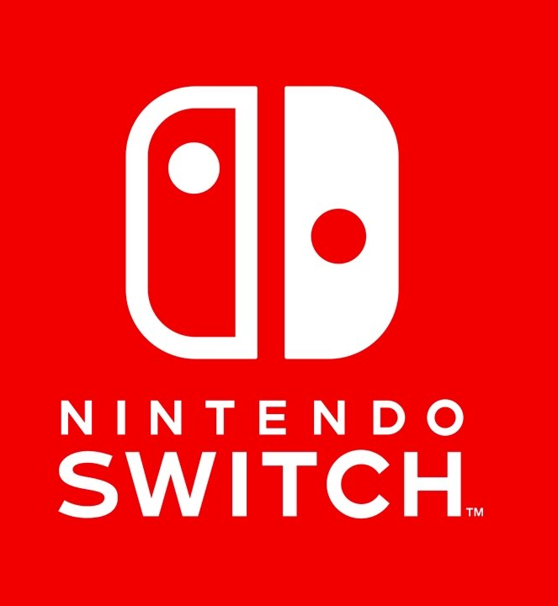

The Nintendo Switch is a new console developed by Nintendo that switches between different methods of playing. There is the home console, gamepad, motion control and portable choices that this console can become. The revolutionary new tech can be used in multiplayer and single player experiences, in both portable and house mode. The Nintendo Switch reaches out to all ages and genders as a family console, for around £300.
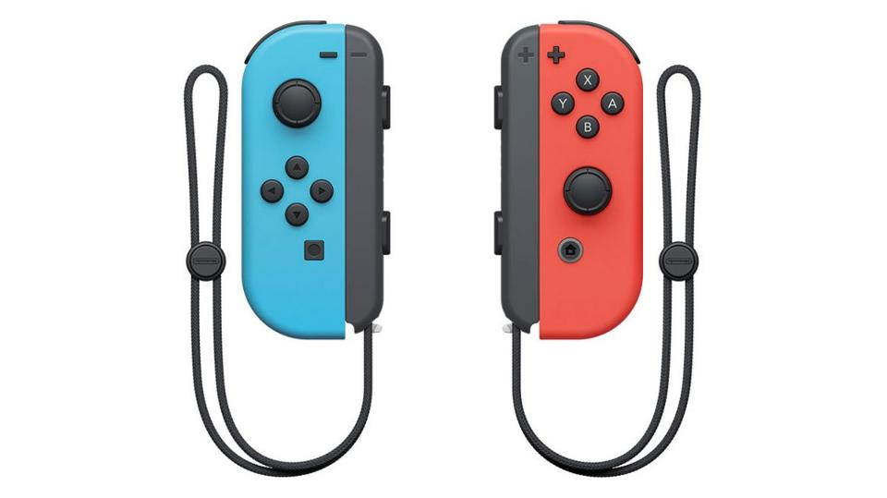

The handheld devices have two settings, the normal controller and the joy con mode. The console has the same high definition visuals as its previous console, but now has a portable screen that can be taken on journeys. The console is even rumoured to be a part of a future plan to make the console have virtual reality (immersing you into a fictional world, e.g. Oculus Rift) and augmented reality (bringing the fictional to the real world e.g. Pokémon GO) features.

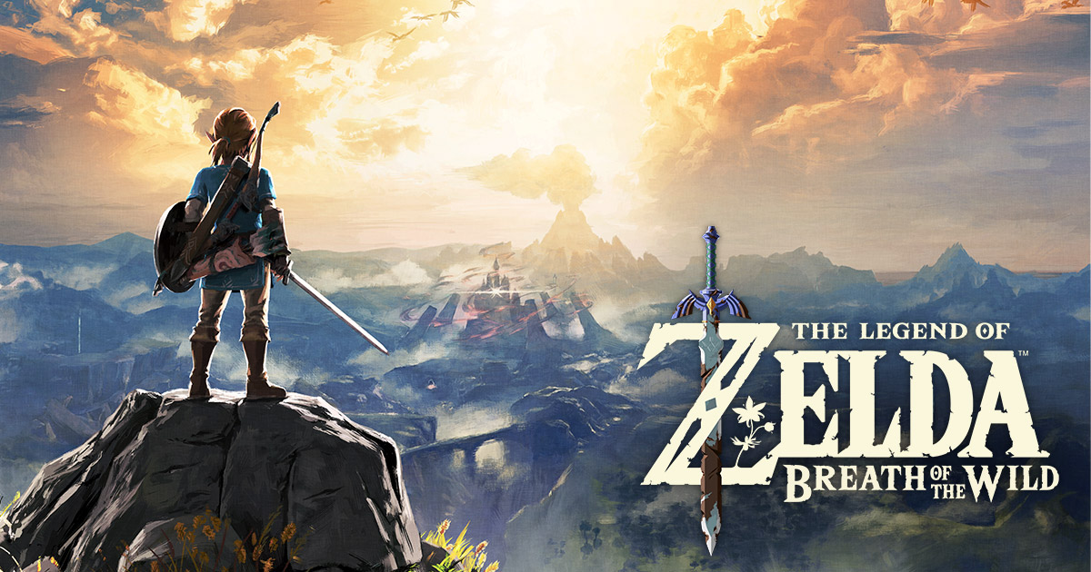
There are three new franchise games being released for the new system: Mario Odyssey, Breath of the Wild, Splatoon 2 and Mario Kart 8 Deluxe. Mario Kart 8 Deluxe is Mario Kart 8 from the Wii U with more characters and altered multiplayer settings, so that people can do room matches. Splatoon 2 is the sequel to the successful third person shooter Splatoon which had colourful gameplay and modern style of characters. Breath of the Wild is the new instalment of the popular Legend of Zelda franchise; it features a larger than life open area and a cinematic story for all fantasy lovers to enjoy. Mario Odyssey is the new Mario game which takes the popular plumber on an open world adventure with beautiful graphics and colourful characters.

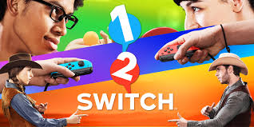

There are also three completely new games to show off the Nintendo Switch’s capabilities: 1-2-Switch, Snipperclips and fast MRX. Fast MRX is a futuristic racing game using the new joy cons to steer the vehicle through obstacle courses. Snipperclips is a fun little puzzle game with different levels to complete. And 1-2-Switch is a compilation of multiplayer mini games that show off the joy cons capabilities, with sensory and motion technology.
Overall, the Nintendo Switch shows potential in overcoming other gaming businesses in the market, and with the theory on extra virtual and augmented reality developments, this could be the system of the future. But for now, the innovative new console has become very popular among fans, with high definition visuals, sensors and more, the Nintendo Switch has revolutionised the home console into something much more.

