General Exam Tips
- Use Classwork notes, Workbooks and Past Exam Papers to revise from
- Revise key terms and definitions from the course (the Revision Guide above will help); and use them in your responses to all questions
- Use the Case Study Items in all of your answers to Unit 11 questions; the data in the Case Study Items is there to 'stimulate responses' (Chief Examiner 2013) - so ensure you write in context!
- A rehearsed or generic answer and/or judgement is likely to score lower marks than an answer which covers the relevant issues highlighted in the Case Study Item and is applied to answer the question directly.
- Exam questions will include command words which signal to you what is required to answer them correctly e.g. state, describe, explain, discuss, analyse and evaluate (use the Exam Guide above to discover what these command words mean).
- Check the number of marks available for each question and use this to guide you in your answer in terms of content, detail and the length of time you spend completing it.
- Spend approximately one minute for every mark available for each question e.g. spend four minutes on a four mark question
- This may sound like common sense but ensure your response answers the question
- Remember to take a calculator into the exam as you may be asked to make some simple calculations e.g. budgeting, exchange rates, interest rates.

How to score high marks for Analysis & Evaluation questions
- Your final grade will largely depend on how well you answer the final question in each of the sections for Money, Work and The National & Global Economy
- To score high marks for these questions the examiners are looking for answers with a logical structure, detailed analysis and evaluation, as well as a clear final judgement.
- Start your answer with a mini-judgement to answer the question directly!
- Follow your mini-judgement with three or four detailed paragraphs which support your judgement; each paragraph needs to follow a 'logical chain of argument' (see example below) which includes analytical and evaluative points!
- Remember to include data from the Case Study Item as well as your own independent knowledge and research to support your points.
- Leave enough time in the exam to conclude your answer with a final judgement paragraph, which is clearly justified and is supported by your paragraphs of analysis and evaluation.
- Economics Online has some useful pointers on how to improve your evaluation skills - click here!
- In the final question the quality of your written communication is assessed - so read your answers back to check your spelling, grammar and use of economic language.
- Remember to check out the Exam Guide above for additional guidance on answering these types of questions!

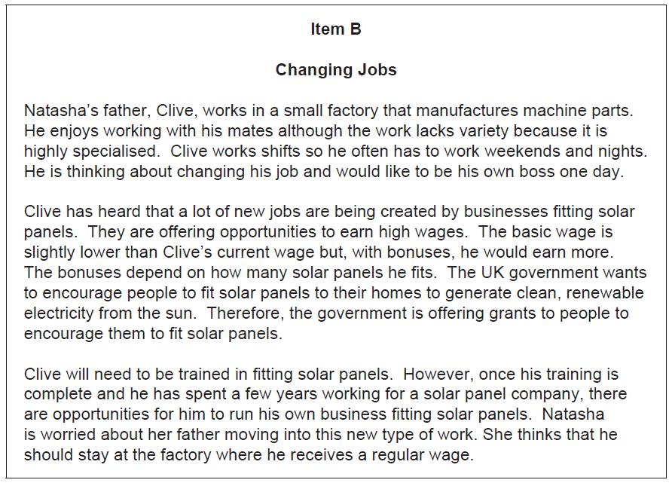

This is an example of a candidate's response to a final question in Unit 11 Remember that these extended questions are marked in two parts; firstly a level is awarded for analysis (L0, L1, L2, or L3) and then a level is awarded for evaluation (E0, E1 or E2).
The Examiner comments for this candidate's response were as follows;
"Fully developed analysis of more than one point meaning this student scores full marks for analysis (L3 = 6marks). There is a substantial judgement paragraph at the end, backed up by a series of points, hence the answer is awarded E2 (5 marks)".
This candidate scored 11 out of the 12 marks available for the question. It's by no means a perfect answer but it provides an example of good practice when answering these questions.

Example answer to an Analysis & Evaluation question

What Went Well
1. The answer starts with a mini-judgement (i.e. stay working at the factory) which addresses and answers the question directly!
2. The candidate puts forwards a balanced argument, starting with the advantages of switching jobs to fit solar panels, before moving on to cover the benefits of continuing to work at the factory, and the drawbacks of not!
3. Each point or argument is justified using a logical chain of argument.
4. The answer concludes with a substantial final judgement which supports what has been said so far and includes a justification for the judgement through simple points.
5. The case study item has been used effectively throughout the answer and to support the judgements of this candidate (e.g. job variety, bonuses, regular wage).
Even Better If
1. Separate paragraphs could have been used for each new point; this provides a clear signal to the examiner when a new point has been made!
2. The answer could have been structured differently to support the mini-judgement first before analysing and evaluating the alternatives.
3. Additional points raised from the case study could have been used to support the judgement of the candidate e.g.Clive would receive a lower wage for fitting solar panels compared to working in the factory; also the government grants given to households to install solar panels may be withdrawn in the future (long term), which will reduce the demand for solar panels, resulting in Clive losing the opportunity to earn bonuses or remain in work altogether should he choose to switch jobs!
Borrowing
Mortgage – a loan to finance the purchase of real estate (e.g. a house). A Mortgage is secured on the house, which remains to be the property of the bank until the loan is paid off.
Credit card – cards that may be used repeatedly to buy products and services on credit or to borrow money up to a pre arranged amount limit. Each month, you must pay back the minimum repayment required (usually around 3-5%) of the outstanding balance. You can pay more if you want, and this will reduce the interest you pay; credit card interest rates are high.
Store card – cards that may be used to buy products and services on credit from the shop that issued the card, up to a pre arranged limit. Repayment terms are similar to credit cards.
Personal loan – a loan given for a personal household (e.g. to buy items such as furniture)
Hire purchase – instalment plan whereby the loan company owns the item, but it becomes yours when the debt if fully paid off.
Overdraft – borrowing up to an agreed limit on a current account. Overdrafts must be paid back on demand.
Type of Loan | Interest Rate | Is security needed? | Flexibility of payments
Mortgages | Low | Yes – The house. | Very little – the amount changes when there are changes in the base rate.
Credit and store cards | High | No | High – you can pay the minimum, or more if you wish
Personal loans | Medium | No | None
Hire purchase | Medium | Yes – the purchase acts as security | None
Overdraft | High | No | High – but make sure that you do not go over the agreed limit.

Borrowing/debt/credit: getting money from a lender that must be repaid in the future (e.g. a mortgage)
Loan: amount of money borrowed
Term of a loan: the length of time over which a loan can be repaid
Annual percentage rate (APR): the interest rate published on loans to help compare their true costs

Money
Basic economic problem: Resources are limited but needs and wants are infinite
Opportunity cost: Something given up when we make a choice
Demand: The quantity of a good or service that consumers are willing and able to purchase at a particular price
Supply: The quantity of a good or service that businesses will offer for sale at a particular price
Bank/building society account: an account for which the main objective is to gain interest and keep money safe.
ISA: individual savings account
Interest Rates: an annual rate which is charged to borrows’ or paid savers
Account | Reward | Risk | Short, medium or long-term | Ease of withdrawing money
Savings account | Low - Medium | Low | Short – Long | Easy – unless notice of withdrawal is required
ISA accounts | Low - Medium | Low | Medium – Long | Easy
National savings and investments account | Low | Very Low | Medium – Long | Often requires written notice of withdrawal
Unit Trusts | Medium - High | High | Long | Obtaining your money may take some time
Annual equivalent rate (AER): a figure quoted in savings advertisements to help people compare on savings products with another
Risks: the chance that something may not succeed and its consequence
Reward: the return received for taking risks
Shares: certificate representing a unit of ownership in a company
Unit trust: a pooled investment fund usually shares-based investments

